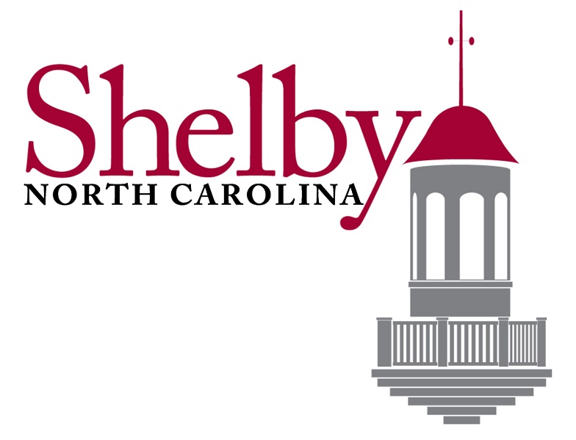

REQUEST FOR QUALIFICATIONS

City of Shelby Mural Project

Deadline for Submission
Friday August 21st, 2020 at 2:00 p.m.

City of Shelby
Purchasing Department
824 West Grover Street
Shelby, North Carolina 28150
(704)484-6851

CITY OF SHELBY
REQUEST FOR QUALIFICATIONS: MURAL PROJECT
I. PROJECT DESCRIPTION
The City of Shelby is soliciting qualifications from artists or a team of artists working collaboratively who specialize in producing large-scale murals. Artists are hereby invited to submit qualifications to be considered to complete a mural project for the City honoring former professional football player and Shelby native Bobby Bell. This request for proposals is open to all professional artists who can fulfill the application requirements.
II. SUBMITTAL DEADLINE
The deadline for submittals will be Friday August 21st, 2020 at 2:00 p.m.
III. INSTRUCTIONS OF SUBMITTAL PROCESS
Submittals can be mailed or delivered to the City of Shelby Purchasing Department located at 824 West Grover Street, Shelby, North Carolina 28150. Qualifications shall be delivered in a sealed envelope with the artists name and project name “Bobby Bell Mural” clearly written on the outside. The City will open each proposal and review for consideration. It is advised to submit all requested information in this document. All information submitted will be reviewed and compared in detail.
IV. METHOD OF AWARD
The award for this contract will be made in the best interest of the City, as determined by the City, based on the qualifications that best meet the needs for the project described in this document.
A qualified committee will be assigned to evaluate each submittal for this project. The committee along with certain City administration will determine which artist/artists will be selected to complete the project.
The selected artist(s) will be contacted by the City of Shelby to begin contract negotiations and project planning.
V. SELECTION PROCESS
The artist(s) submittals will be evaluated on the following criteria:
- Artistic merit as evidenced by submitted representation of past work
- Appropriateness of the artist’s medium, style, and previous professional experience as they relate to the art goals and opportunities in this project
- Experience with projects of similar scale and scope, including familiarity with public agencies and the public review process
- The ability of the artist to successfully complete the proposed artwork within the desired timeline

VI. SUMITTAL REQUIREMENTS AND REQUESTED INFORMATION
- Completed and signed application form and checklist (see attached)
- List and complete a description of the previous 5 mural projects. Each sample should include.

  - Photo
  - Location of work
  - List of materials used, including but not limited to the paint system (type of primer, type of paint, type of finishing)
  - Dimensions and scale
  - Approximate budget
  - Warranty and guarantee for each project

- List artistic style of previous work. (Abstract, Landscape, People, etc.)
- Describe how wall is prepared to receive paint.
- Description of warranty and guarantees offered
- Include Certificate of Insurance detailing current coverages
VII. SITE
The site for this project has not been selected at the present time. However, the City will work closely with the artist(s) if there is a need for protected space or lane closures.
Note: The artist(s) is required to supply all necessary supplies, machines, or devices needed for the completion of described work.
VIII. AVAILBILITY
Please describe in brief your current workload and when you would be available to begin the project described.
CONTACT INFORMATION
If you have any questions, please contact Todd Frashier at 704-484-6851 or by email todd.frashier@cityofshelby.com, or Shelby Holmes at 704-484-6800 or by email shelby.holmes@cityofshelby.com.

APPLICATION FORM: PUBLIC ART INSTALLATION

NAME: ____________________________ DATE: ____________________
ADDRESS: ___________________________________________________
CITY: _______________ STATE: _________________ ZIP: _____________
PHONE (DAY): _______________ PHONE (EVENING): _________________
EMAIL: _______________________________
WEBSITE: _____________________________

To assure that your application is complete, please check off the following items as enclosed:
☐ This application form completed and signed
☐ Past Project Description
☐ Supporting Materials
☐ Description of Warranty and Guarantee
☐ Proof of Insurance
☐ Description of Current Workload and Availability
Certification
I certify that as of the date of this application I am 18 years or older, as are any members of my team (if applicable). I certify that all examples of artwork submitted with this application are products of my design and fabrication as represented. If accepted, the artwork produced will be owned by City of Shelby, and images of my work may be used in publicity for the City of Shelby and its assigned.
I certify that all statements made in this application are true to the best of my knowledge. I acknowledge that the City of Shelby is not liable for loss or damage to work submitted.

APPLICANT SIGNATURE: ________________________DATE: __________

