For 50-years, the North Carolina Arts Council has achieved breakthroughs in education, arts-driven economic development and cultural enrichment. Your partnership in these collective achievements has set the stage for an exciting future of growth for the arts in North Carolina.
Much of our success can be tied to how we present our collaborations to the public. Below are requirements for use of the North Carolina Arts Council logo and 50th anniversary tagline. Organizations that receive funding from the N.C. Arts Council directly or through a subgrant by their local arts council, are required to recognize the N.C. Art Council’s investment in your program.
Please find below the requirements about logo use and credit line. Please also visit the North Carolina Arts Council’s 50th anniversary website at NCArts.50.org to discover additional content that can be shared via the web and social media.
Logo Use and Credit Line
The North Carolina Arts Council logo must be prominently displayed on-site and in all publicity and printed materials.
Credit Line
Printed material and publicity regarding North Carolina Arts Council grants, funded activities, and/or partnerships must contain the following language with the appropriate logo(s):
This project was supported by the North Carolina Arts Council, a division of the Department of Natural and Cultural Resources.
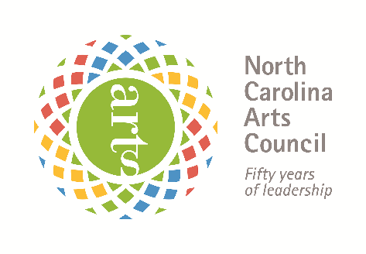
Example:

This project was supported by the North Carolina Arts Council, a division of the Department of Natural and Cultural Resources.

Reproducing the Arts Council Logo
Grantees may download a print quality logo from the N.C. Arts Council’s website at
http://ncarts.org/resources/grants/logo-use. Do not reproduce the logo from faxed or photocopied images.
The logo must be reproduced as a unit without alteration. The logo may be no smaller than 1″ wide. The circle with the word “ARTS” must be a least the size of a nickel, although the size of a quarter is preferable. Please see the Visual Guide.
The NEA logo can be used anytime, but unless your project receives federal funds, it is optional. The NEA logo can be downloaded from https://www.arts.gov/grants/manage-your-award/nea-logo.
Donor Recognition

If your organization lists donor participation in printed materials or on your website, you must list the North Carolina Arts Council in the appropriate category (i.e. Benefactors $25,000 – $49,000, Directors $10,000 – $24,999, Sponsors $5,000 – $9,999, etc.). For radio, television and non-written announcements, please use the credit line language.
In written communication, North Carolina Arts Council should always be written out on first reference. We prefer: North Carolina Arts Council or N.C. Arts Council on second reference.
Web and Social Media usage:
We encourage you to place the N.C. Arts Council logo on your website and in your
e-newsletters and link it to NCArts.org. Arts Organizations are also encouraged to join the North Carolina Arts Council social media network and tag NCArts.
Facebook: https://www.facebook.com/ncarts
Twitter: https://twitter.com/ncartscouncil
Instagram: https://www.instagram.com/ncartscouncil/
YouTube: https://www.youtube.com/user/NCArts

